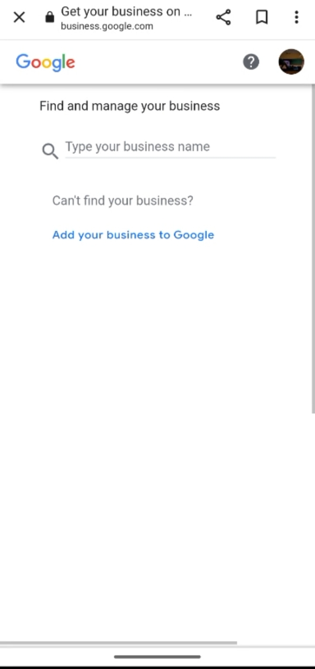

GO TO GOOGLE BUSINESS PROFILE WEBSITE

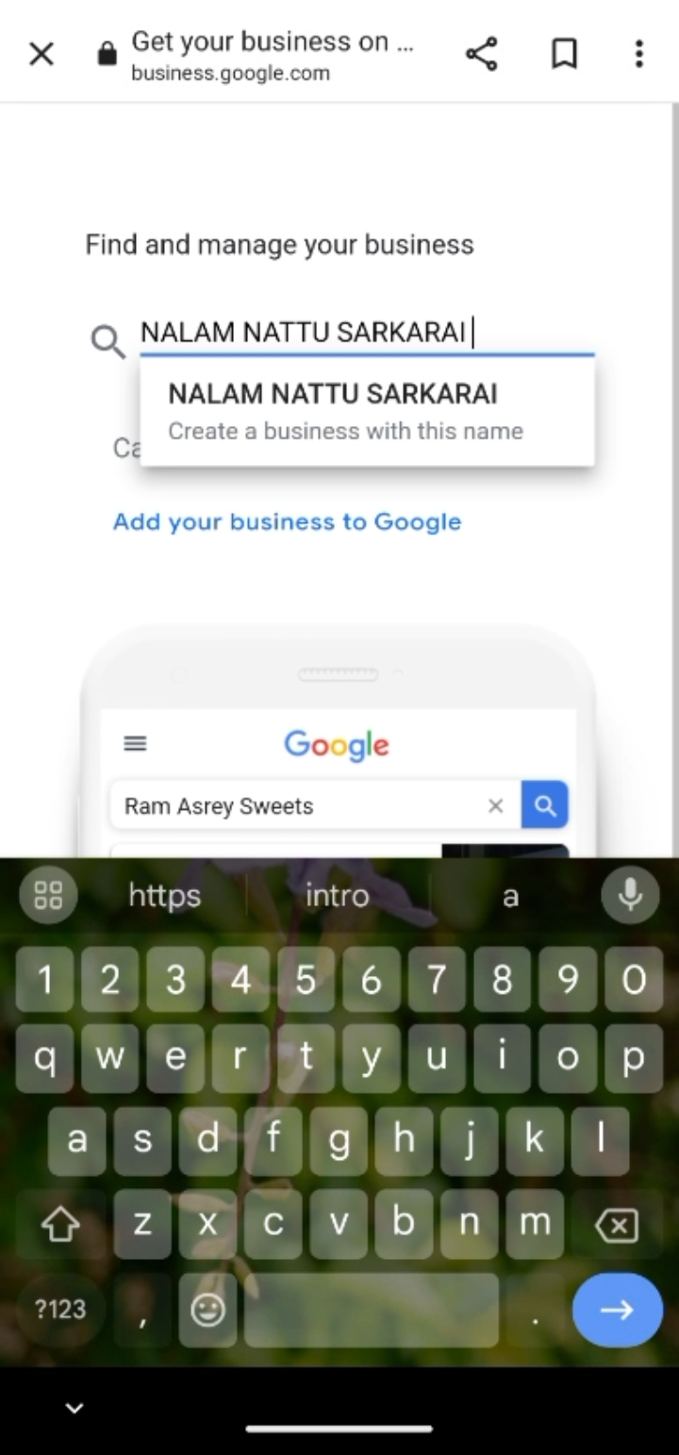

CLICK CREATE ACCOUNT AND ENTER YOUR BUSSINESS NAME

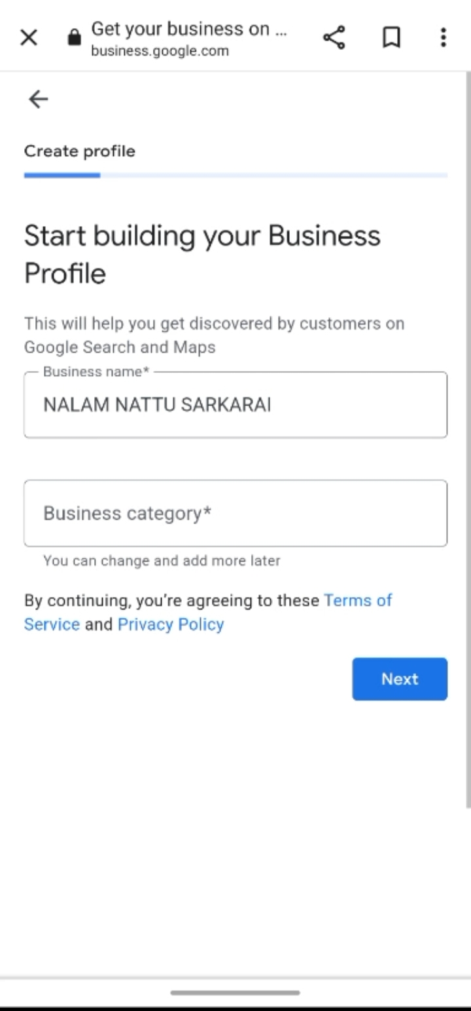

NOW ENTER THE CATEGORY OF YOUR BUSINESS NAME

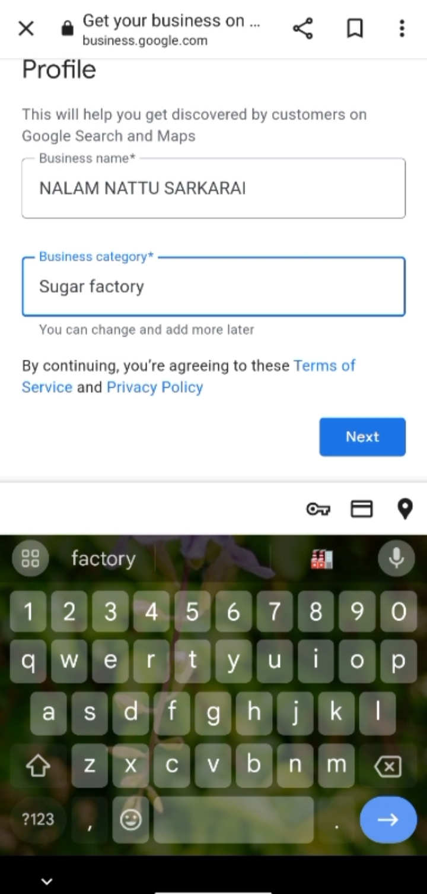

CLICK \*NEXT\*

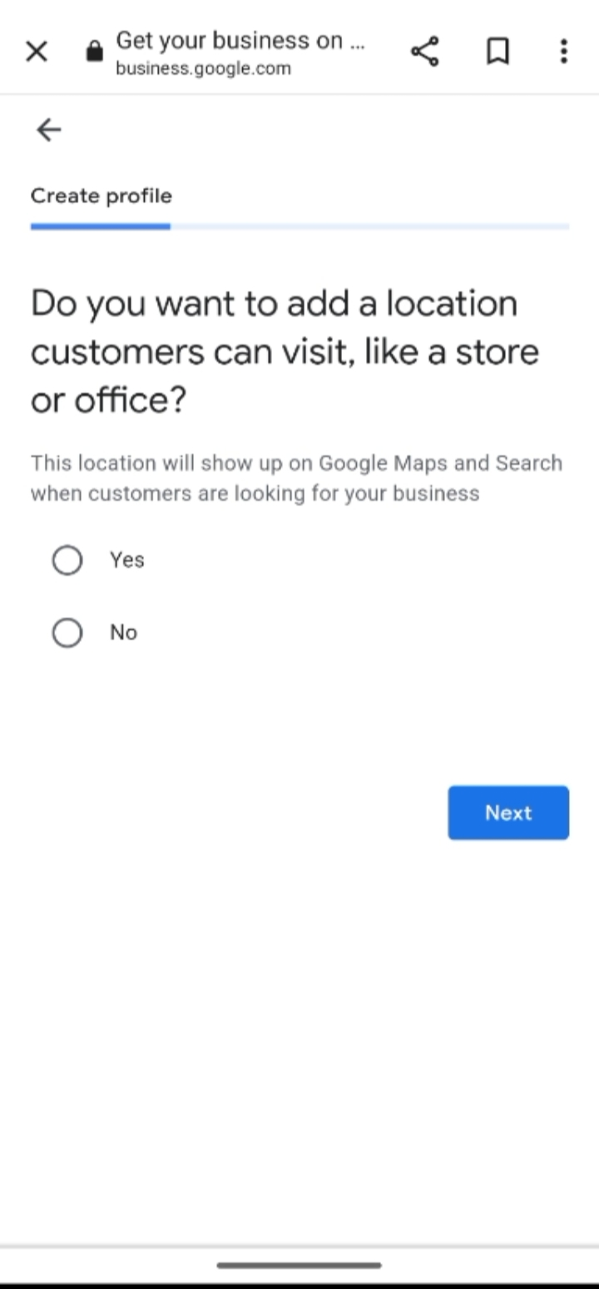

CHOOSE WHETHER YOU HAVE A LOCATION THAT CUSTOMERS CAN VISIT

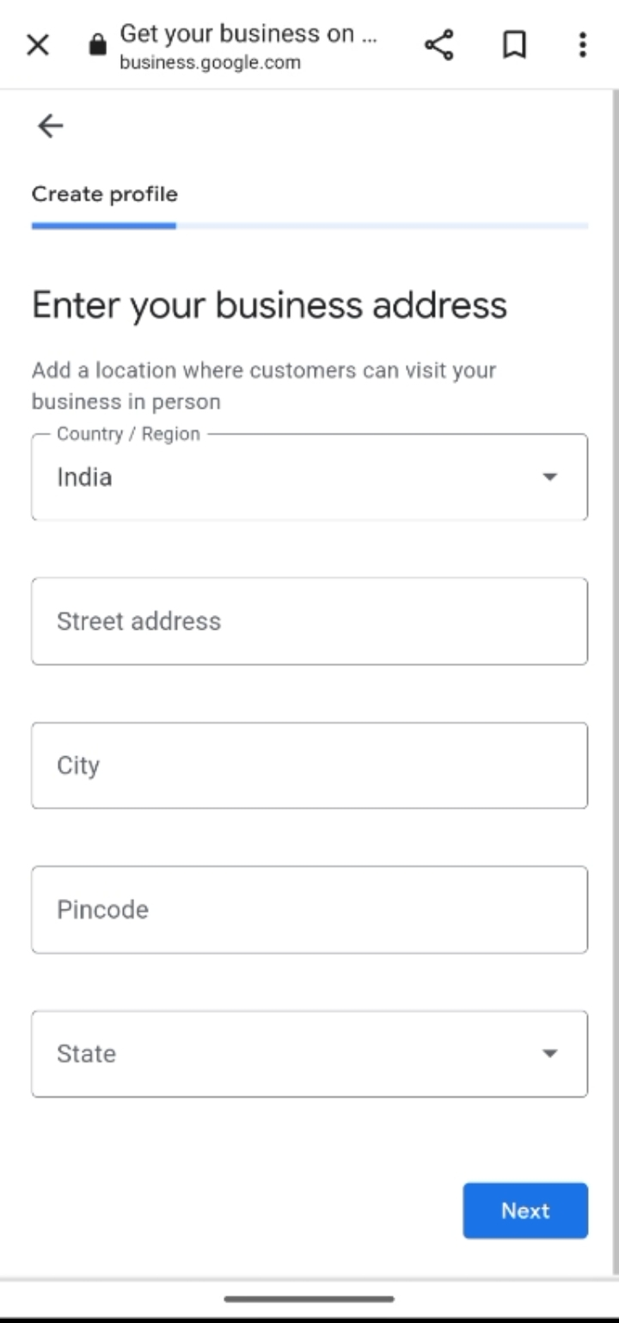

IF YOU HAVE A LOCATION,ENTER YOUR BUSINESS ADRESS

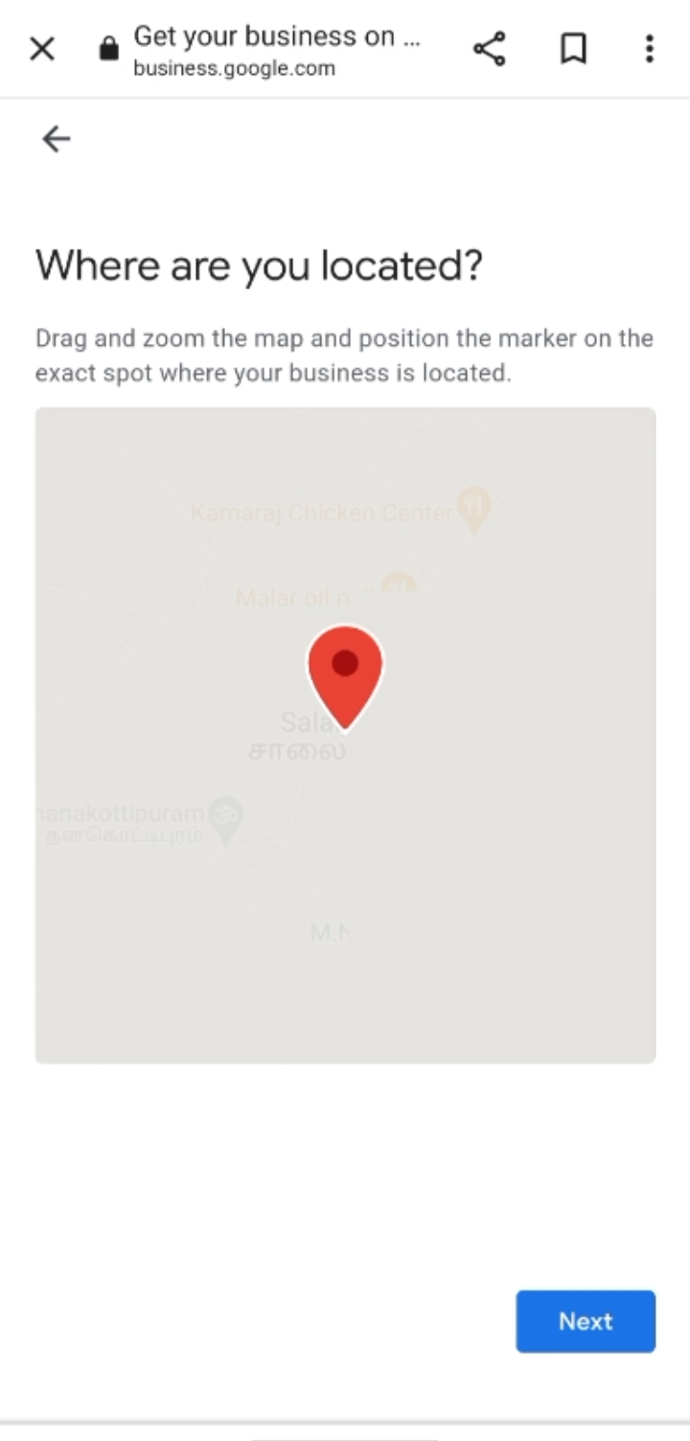

PLACE A MARKER ON THE MAP

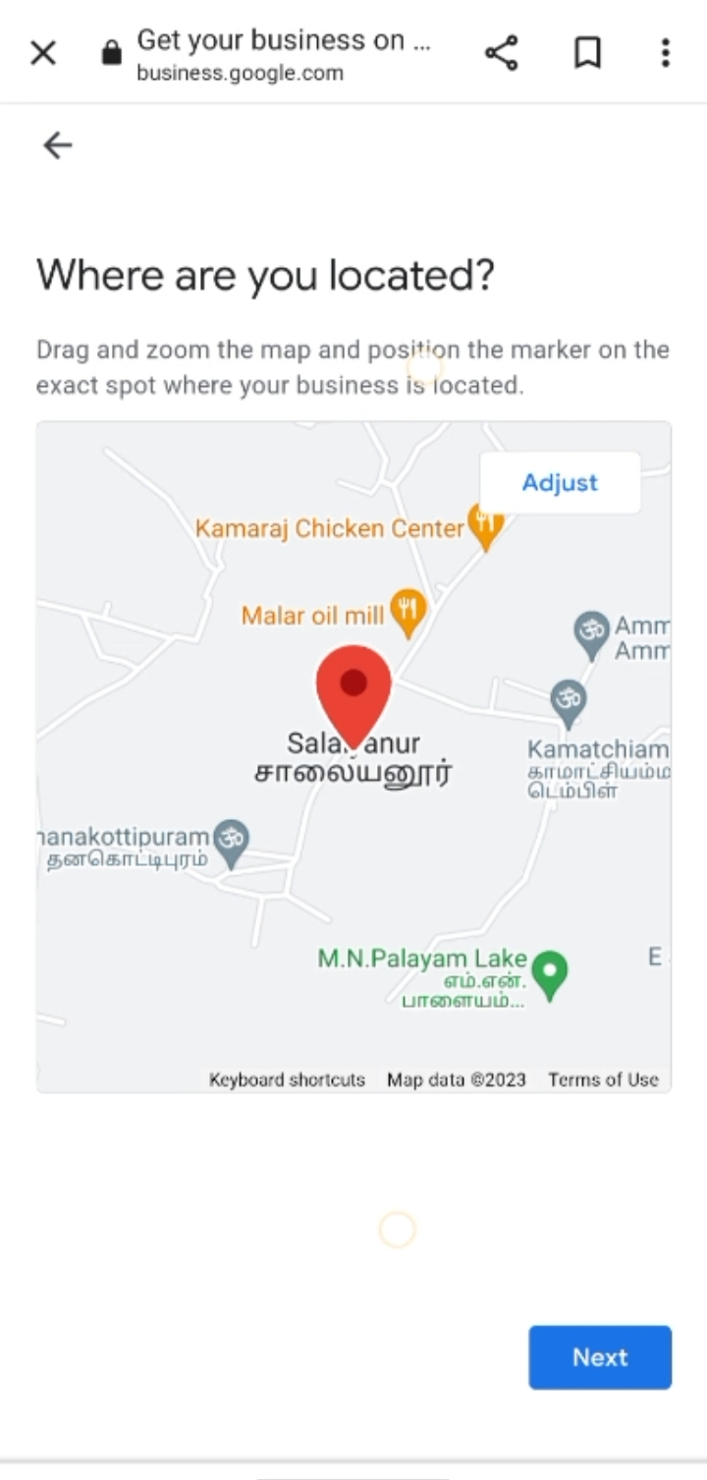

ADJUST THE PIN TO THE LOCATION AND CLICK ON THE NEXT

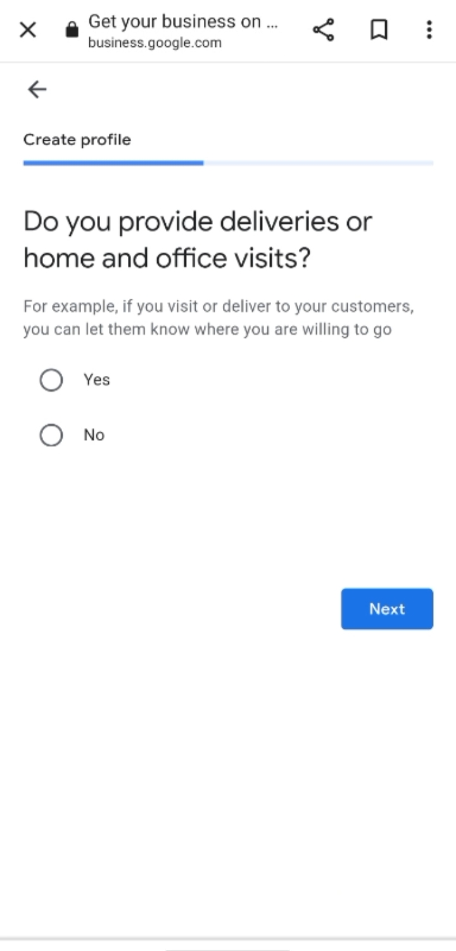

DO YOU PROVIDE DELIVIRIES OR HOME AND OFFICE VISIT CLICK \*YES\* OTHERWISE CLICK \*NO\*

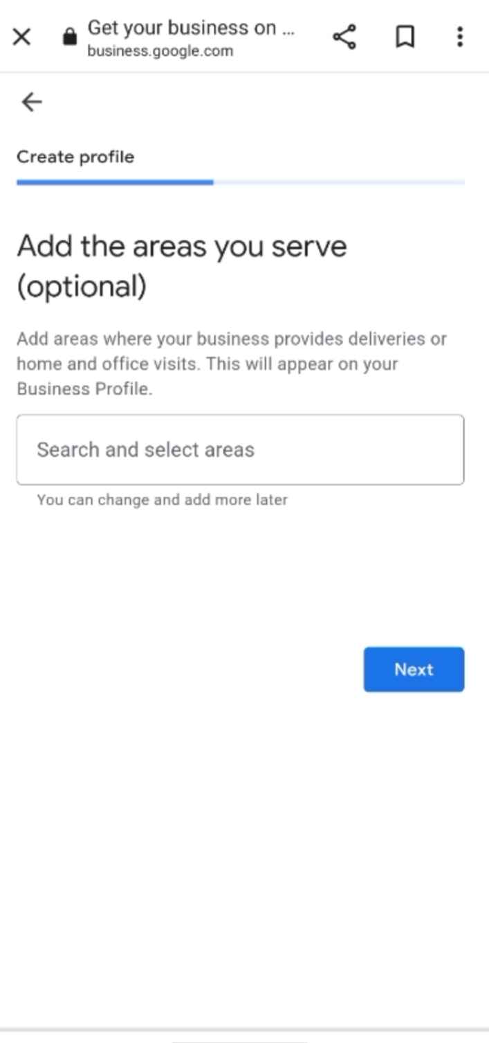

ADD THE ADRESS YOU SERVES TO THE CUSTOMER

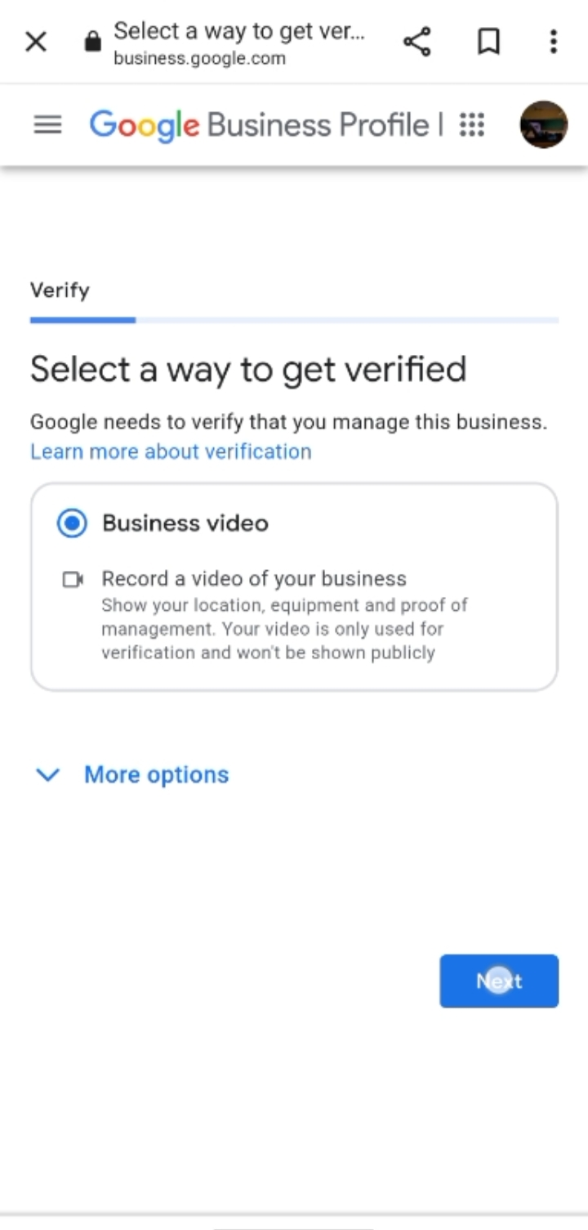

SELECT THE WAY OF GET VERIFIED

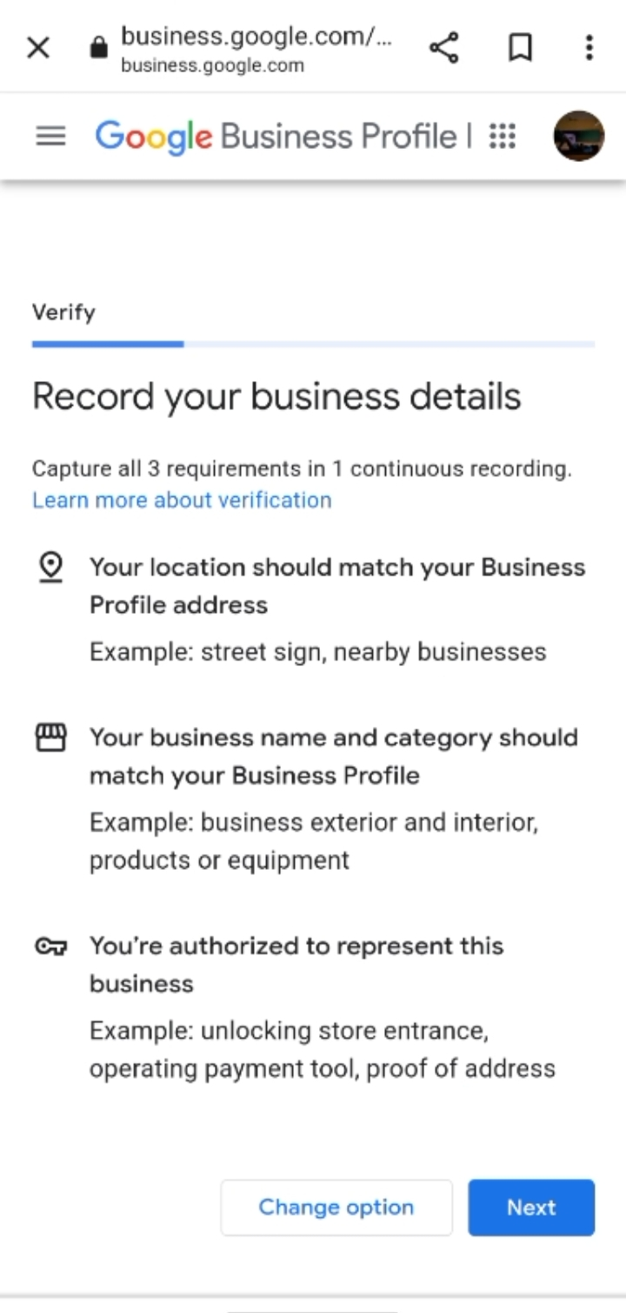

READ THE INFORMATION ABOUT YOUR BUSINESS

IF ANY CHANGES REQUIRES CLICK ON CHANGE OPTION

CLICK ON \*NEXT\*

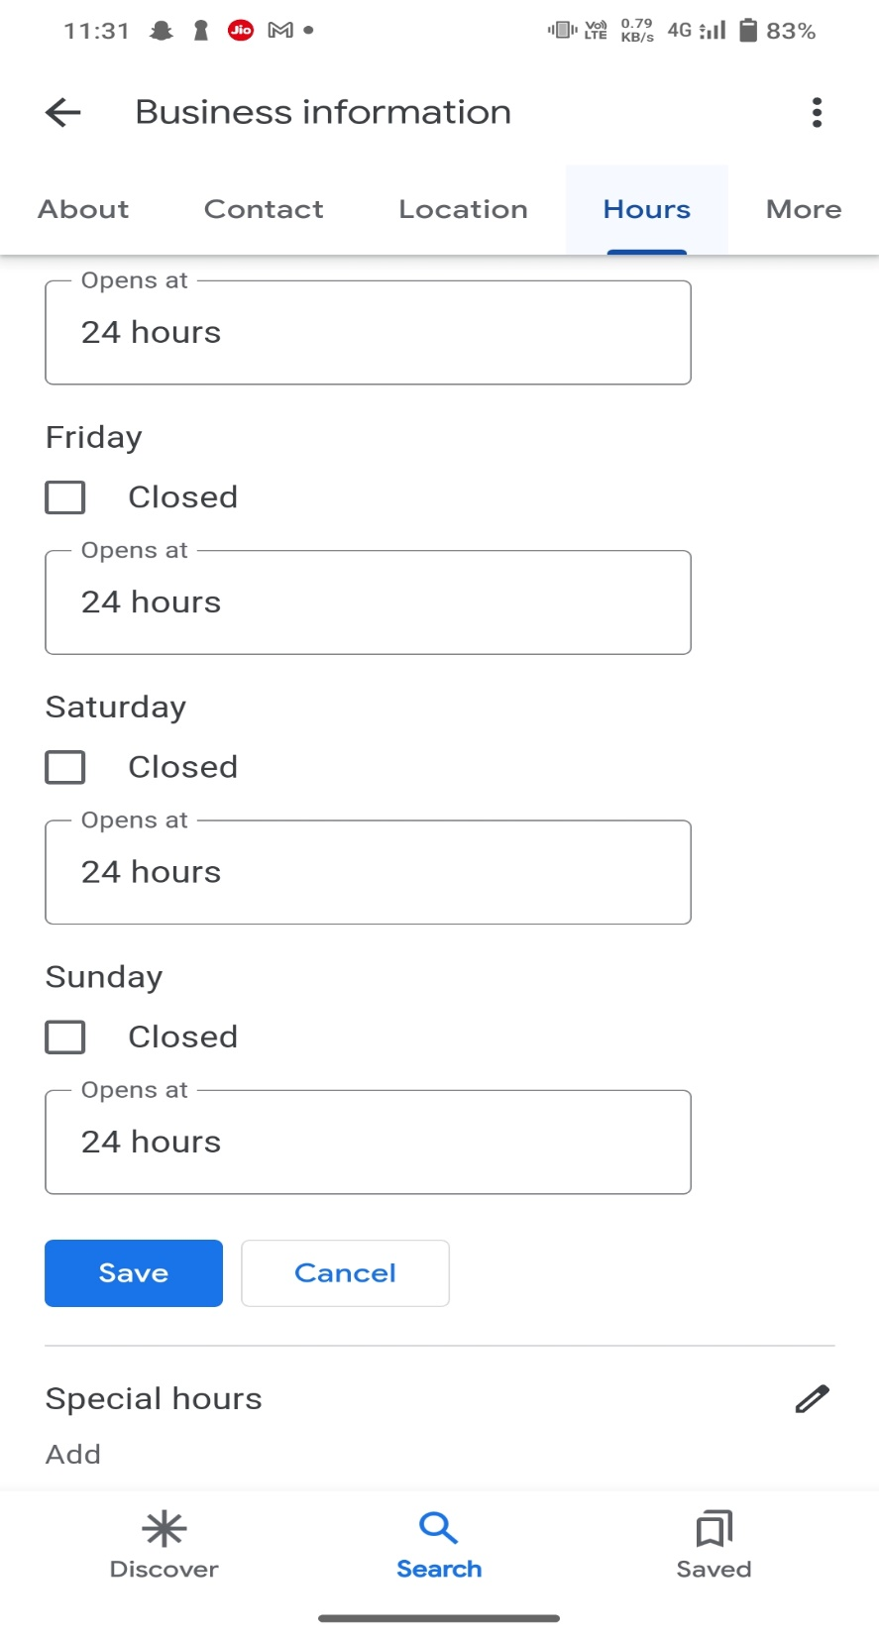

ADD YOUR BUSINESS DAYS AND HOURS

CLICK NEXT

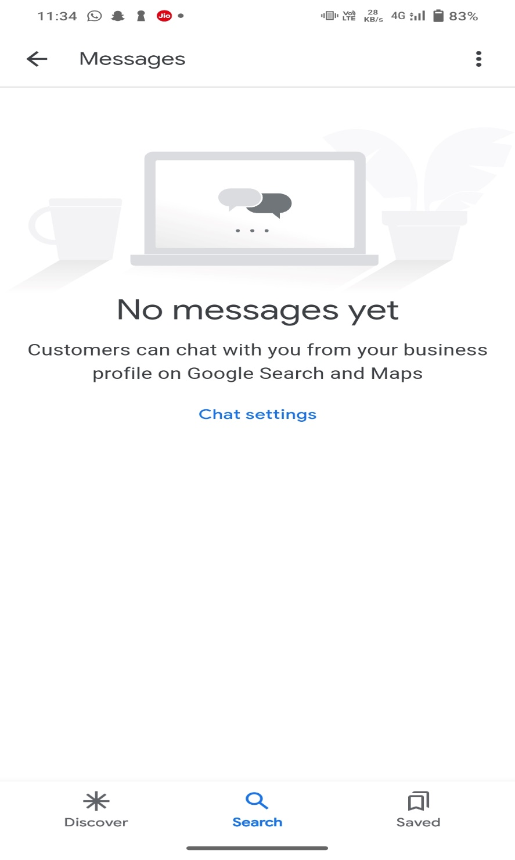

ADD MESSAGING FEATURES IF NEED AND CLICK NEXT

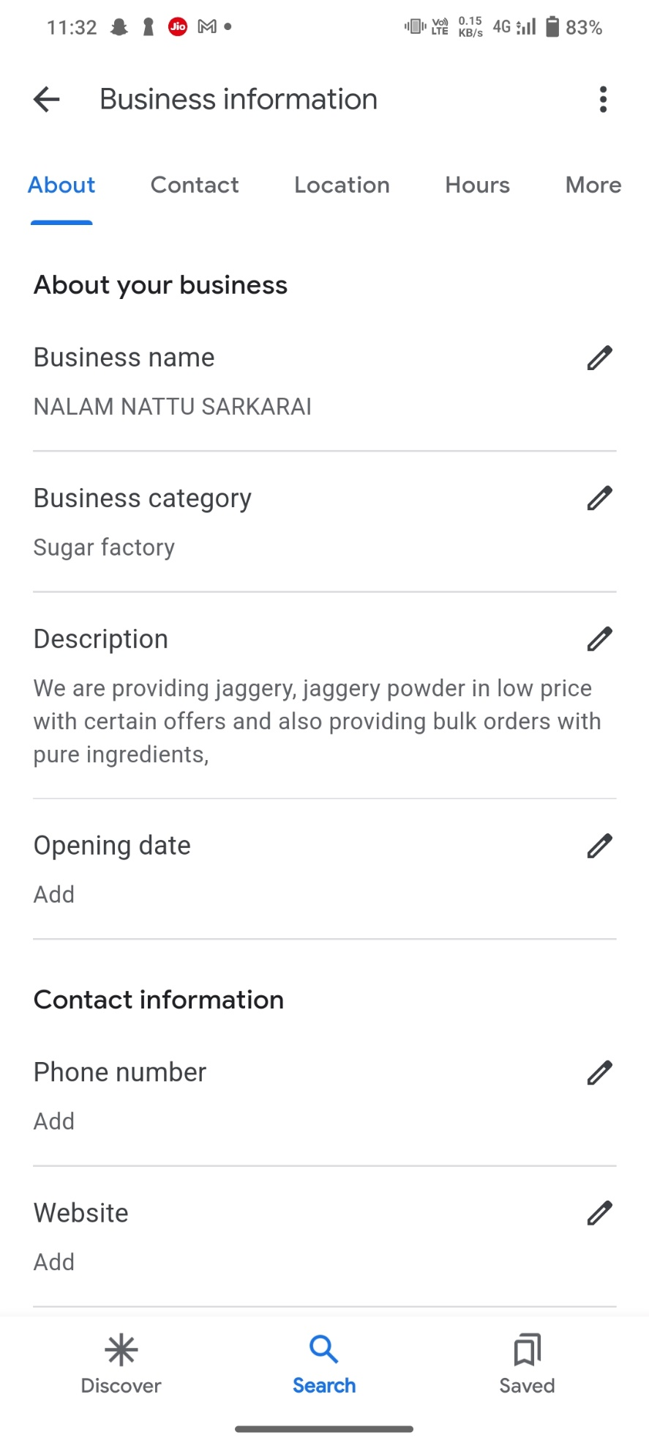

\*DISCRIPTION\* THIS WILL EXPLAIN ABOUT YOUR BUSINESS

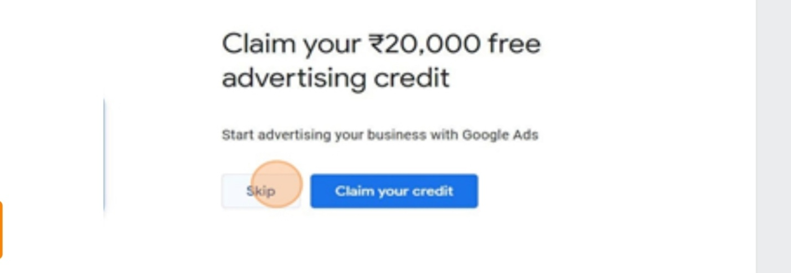

EXPLAIN ABOUT CLAIM YOUR BUSINESS

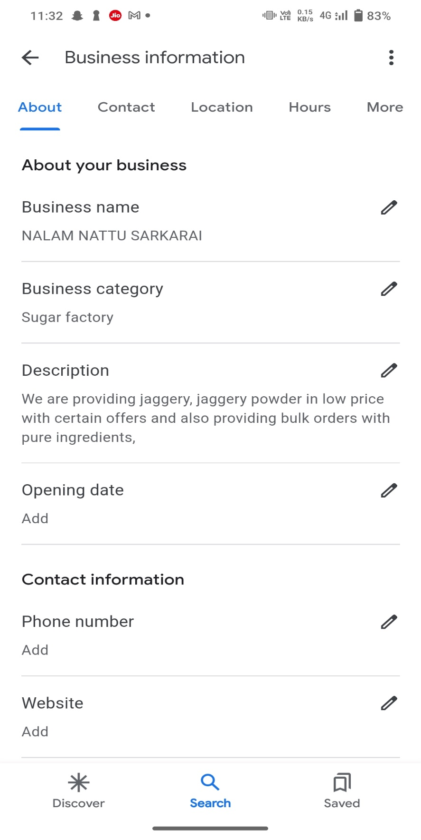

CLICK EDIT PROFILE AND YOU CAN EDIT YOUR PROFILE

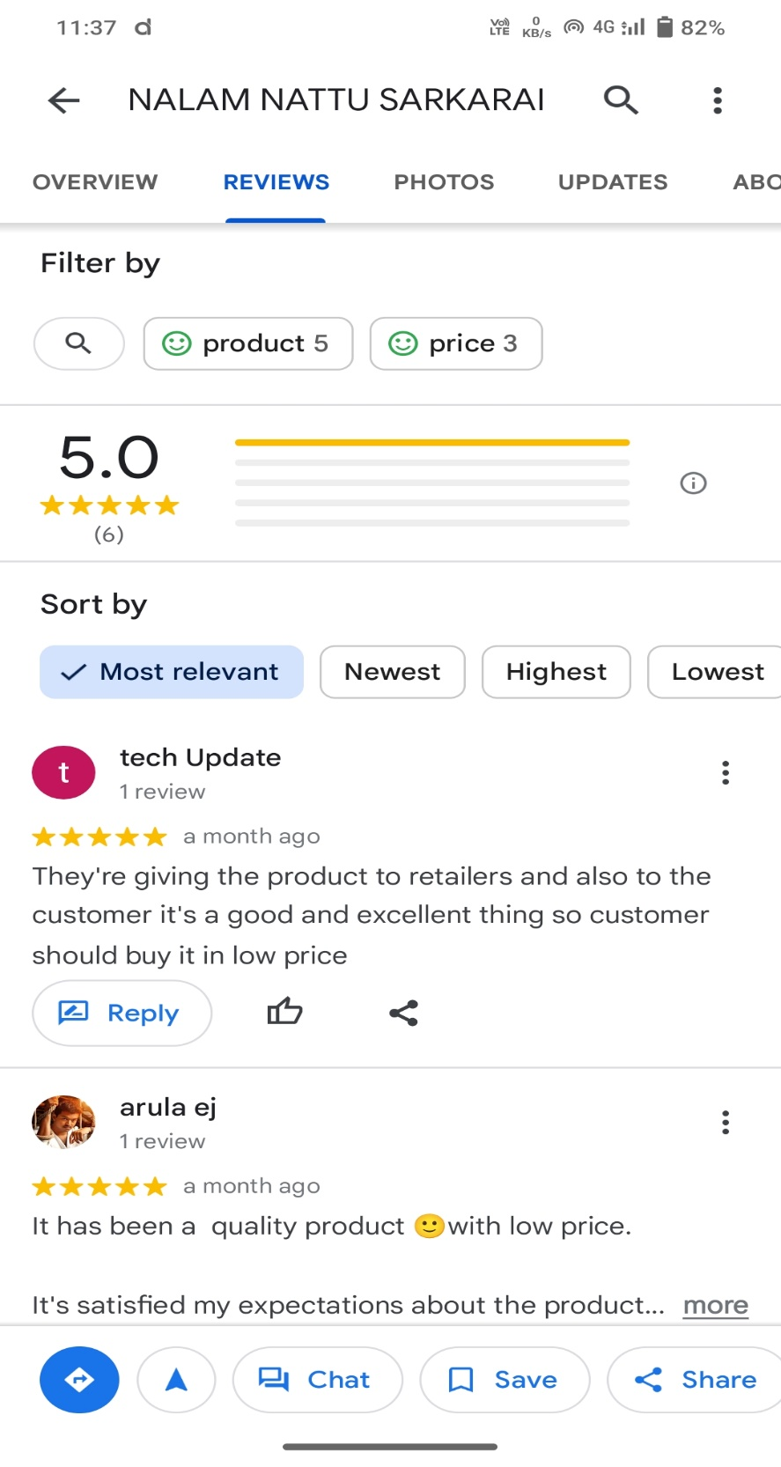

CLICK READ REVIEWS TO READ THE REVIEWS OF YOUR CUSTOMER

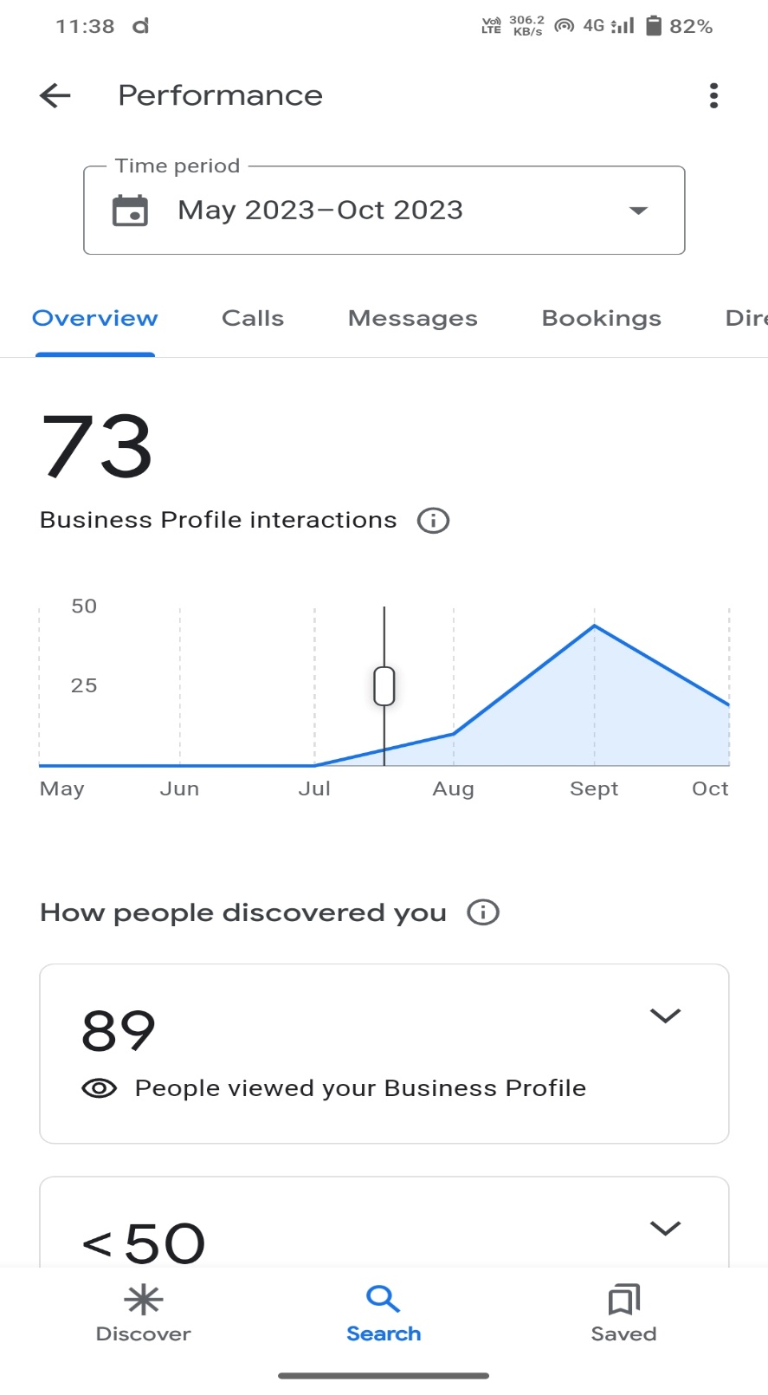

CLICK PERFORMANCE TO VIEW HOW YOUR BUSINESS PERFORMED

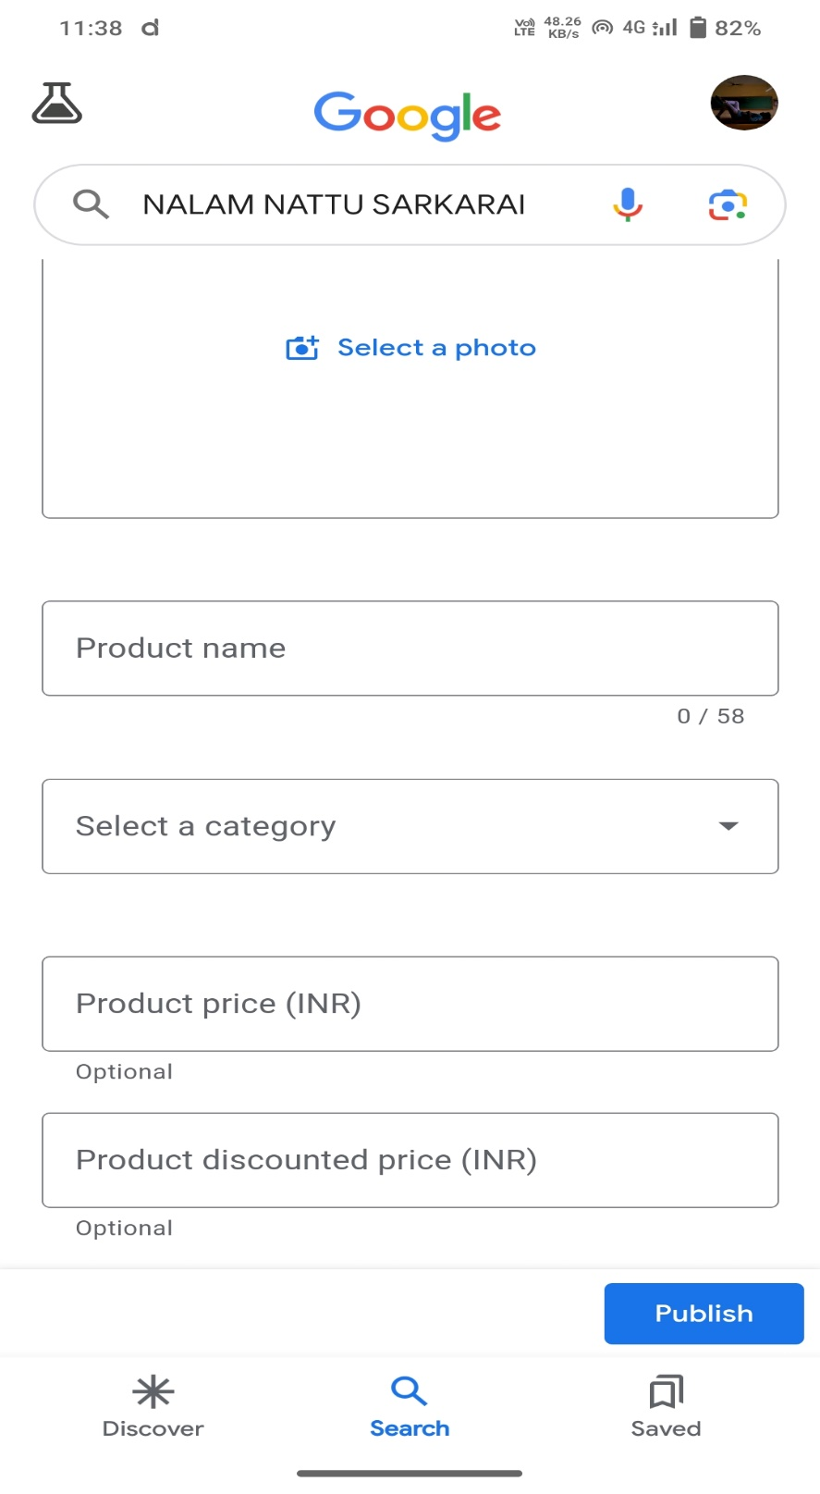

CLICK EDITN PRODUCTS TO ADD OR UPDATE YOUR PRODUCTS